The Rt Hon Patrick McLoughlin MP
The Secretary of State for Transport
The House of Commons
London SW1A 0AA 5th December 2012

Sent By Email

Dear Patrick,

As founder & campaign director of the Dual the A1 Campaign for dualling from Morpeth to the Scottish Border, I was encouraged to hear the Chancellor respond with warm words in the House earlier today about the potential for looking at investing in Dualling the A1 still undualled, from Morpeth to the Scottish Border.

The reality is, however, that at the present time there is no costed model for this desperately needed investment. Despite our campaigning efforts to date, we have so far not persuaded your Transport officials to put the road through the financial modelling process required to find out what the up-to-date costs and cost benefit analysis for dualling these 37 miles of undualled A road would be.

The previous Transport Minister Mike Penning MP gave us some guidance on the issues which require further work – that is, to show to the Department that there is an economic development case for the level of investment which would be required to dual the remaining A1 to the border. As a small campaign team, working with a few willing volunteers, we are working with regional businesses to gather data on the economic impacts this road investment would have on their business outputs. This is a difficult task to achieve effectively and on a large scale without greater input & assistance from Government officials.

I would therefore ask whether you would be willing to meet with me to discuss this matter in detail. There is unequivocal cross-party support for this dualling, and Alex Salmond told me a few weeks ago that he would look again at finishing the last 8 miles of undualled road on the Scottish side of the Border if there was commitment from London to invest in Northumberland.

I hope very much that you will be willing to meet with me, so that the North East region has the opportunity to talk as one voice about the economic impact that not being cut off by a farm track could have on inward investment & business development for existing and future businesses in the North East and across the UK.

With many thanks for your time & I look forward to meeting with you in the New Year.

Yours sincerely,
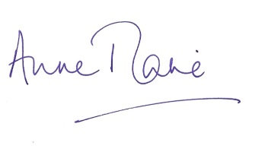
Anne-Marie Trevelyan

